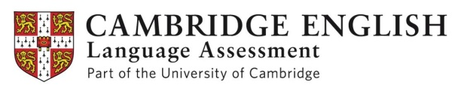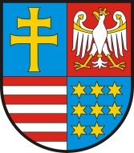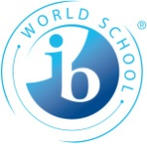

Conference on "Bilingualism - a Wealth of Opportunities"
organised as part of the project Bilingual Świętokrzyskie Region
by
Marshal of the Świętokrzyskie Voivodeship, Adam Jarubas,
in co-operation with
Cambridge English Language Assessment
(University of Cambridge)
&
Juliusz Słowacki Secondary School in Kielce
(International Baccalaureate Diploma Programme)

Date: 6th November, 2015
Venue: Seat of the Philharmonic Orchestra in Kielce, 12 Żeromskiego Str.

09.30-10.00 Registration

10.00-10.15 Official opening (with Marshal Adam Jarubas delivering a welcome speech);

10.15-10.40 'Clarity is all: Cultural differences between the Polish and British mindset, and how they affect language.' Michael Dembiński (UK), Chief Economic Advisor to the British-Polish Chamber of Commerce;

10.40-10.55 ‘The attitude in foreign language acquisition’, Andrzej Łukasik, International Co-operation Advisor to Marshal of the Świętokrzyskie Voivodeship;

10.55-11.10 ‘Cambridge English – prepare yourself for a bright future’, Mariusz Prot, Cambridge English Language Assessment;

11.10-11.25 ‘Unusual language interactions‘, Robert Cassettari, English teacher (Australia);

11.25-12.00 Coffee break

12.00-12.15 ‘My Languages, My World’, Maria Rita Foti, student of Jagiellonian University, novelist, translator, polyglot;

12.15-12.25 ‘Going bilingual’, Igor Kacperski, student of Maria Skłodowska-Curie Secondary School in Końskie;

12.25-12.50 Student panel discussion, ‘Balancing between languages, balancing between cultures’,
Olivia Masoja, Juliusz Słowacki Secondary School in Kielce,
Mikołaj Marcinkowski, Jan Śniadecki Secondary School in Kielce,
Aleksandra Lipecka, St. Stanislaus Kostka Secondary School in Kielce,
Adam Koczoski, Juliusz Słowacki Secondary School in Kielce;

12.50-13.00 ‘Two foreign languages within reach’, Krzysztof Łakomiec, student of Juliusz Słowacki Secondary School in Kielce;

13.00-13.15 Conclusions.

